2021 IABC World Conference
Exhibitor/Sponsor Marketing Kit

About this Marketing Kit
As an exhibitor and/or sponsor of the 2021 IABC World Conference, we know that you’re eager to spread the word about the conference’s offerings and experiences. We’ve created this marketing kit to help you share your excitement about the conference.

To support our outreach efforts, we ask you do any or all of the following:

- ENCOURAGE ATTENDANCE – Send an email to your colleagues and clients using the template below.
- PROMOTE THROUGH YOUR ORGANIZATION – Add the 2021 IABC World Conference to your organizational and work calendars, newsletters and digital bulletin boards using the template below.
- LIKE, RETWEET AND USE THE #IABC21 HASHTAG – Encourage attendance and spread awareness of the 2021 IABC World Conference.

Conference Details
Included below are important conference details that you may reference and use when spreading the word about the 2021 IABC World Conference.

Dates
28–30 June 2021

Location
Online

Website
https://wc.iabc.com/

Social Media Hashtag
#IABC21

Social Media Channels
Facebook https://www.facebook.com/IABCWorld
Twitter
https://twitter.com/iabc
YouTube https://www.youtube.com/user/IABClive
LinkedIn https://www.linkedin.com/company/iabc/
Instagram
http://instagram.com/iabcsnaps

Sample Email Communication
The following message was developed for your ease of use; copy and paste, or modify the message to send via personal email to your network of coworkers, colleagues and professional contacts.

Subject: Visit [Insert Company] at the 2021 IABC World Conference

Dear [Contact Name],

[Insert Company] understands the importance of adapting and delivering vital communications in the midst of a quickly changing environment. That’s why we are excited to share that we will be partnering with IABC at their forward-thinking global event: the 2021 Virtual IABC World Conference.

This June, [Insert Company] will be featured in the virtual Exhibit Hall at the World Conference. We are excited to be a part of this unique experience and to share our [Insert product/service] with a group of innovative communications professionals.

The 2021 Conference theme, It’s About Time, is designed to help us as professionals progress and meet the evolving needs of our communities. We hope to help you accomplish “it,” no matter what “it” is to you: inspiration, new perspectives, innovation, and more. I look forward to joining IABC, 28-30 June, and “It’s About Time” you join me!

Make sure that you secure your registration – at a significantly reduced price compared to an in-person event – so that we can virtually connect this June.

Sincerely,
[Your Name]

Sample Social Media Posts
Use these customizable social media posts to share the 2021 IABC World Conference with your personal and professional network. Don’t forget to use #IABC21 and tag IABC when you post!

Sample One
[Insert Company] is so excited to be featured at #IABC21, happening 28–30 June! Connect with us at the virtual Exhibit Hall to hear more about [insert product/service]. Register here: www.wc.iabc.com

Sample Two
Join [Insert Company] 28–30 June for #IABC21 to network, learn and explore with dozens of global speakers and thousands of #comms professionals. Register here: www.wc.iabc.com.

Sample Three
It’s About Time: for inspiration, for innovation, for new perspectives… and to join [Insert Company] at #IABC21! Register to attend the virtual event from 28–30 June. You’ll save hundreds on travel and hotel costs while still receiving the same caliber of education and networking. Will I see you there? www.wc.iabc.com

Sample Four
Communications professionals have proven their expertise and necessity in the face of constant change. #IABC21 will help you grow your professional skills and network, while advancing the #comms profession. Learn more and register to join [Insert Company] (virtually) 28–30 June: www.wc.iabc.com.

Calendar, Newsletter and Bulletin Board Event Description
Use this event description to share via calendar event, newsletter or digital bulletin board.

2021 IABC World Conference
The 2021 IABC World Conference is once again going virtual! We are excited to take advantage of the opportunities of a virtual conference, including lower registration fees, increased access to a global audience to network with, access to session recordings, and more! Join us from anywhere in the world 28–30 June.

With dozens of global speakers covering today’s pressing topics, you can expect a diverse education experience from experts who are second to none in their field.

Plus, while enhancing your communications skillset, you can also develop professionally by networking and forming connections with other attendees and top exhibitors.

Learn more and register today at www.wc.iabc.com.

Email Signature
Add the below copy and graphic to your email signature to help spread the word of the conference. Don’t forget to hyperlink the image.

Join me at the 2021 IABC World Conference, happening virtually 28-30 June!

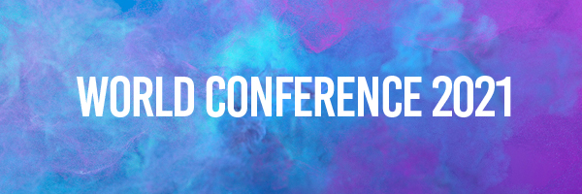

Event Graphics
Save the below graphics to help promote the conference in emails or on social media.

SOCIAL:
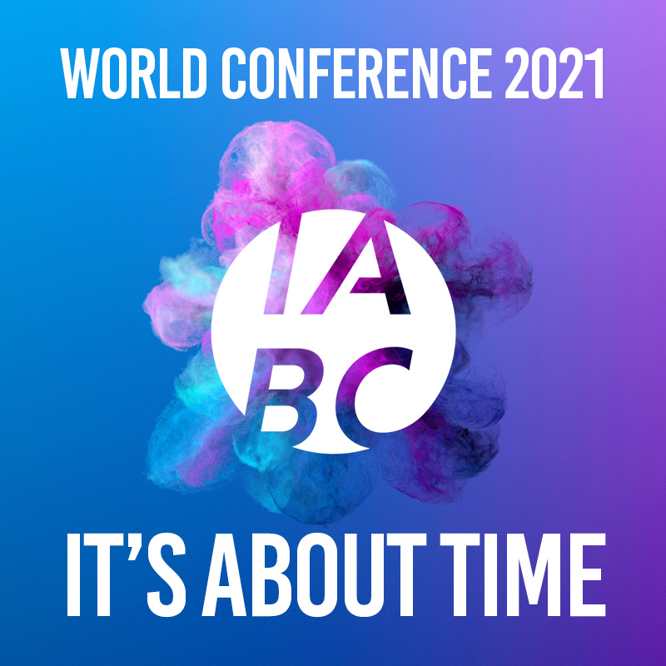
EMAIL:
